SmartBear Webinar – State of APIs 2016

Mar 23, 2016

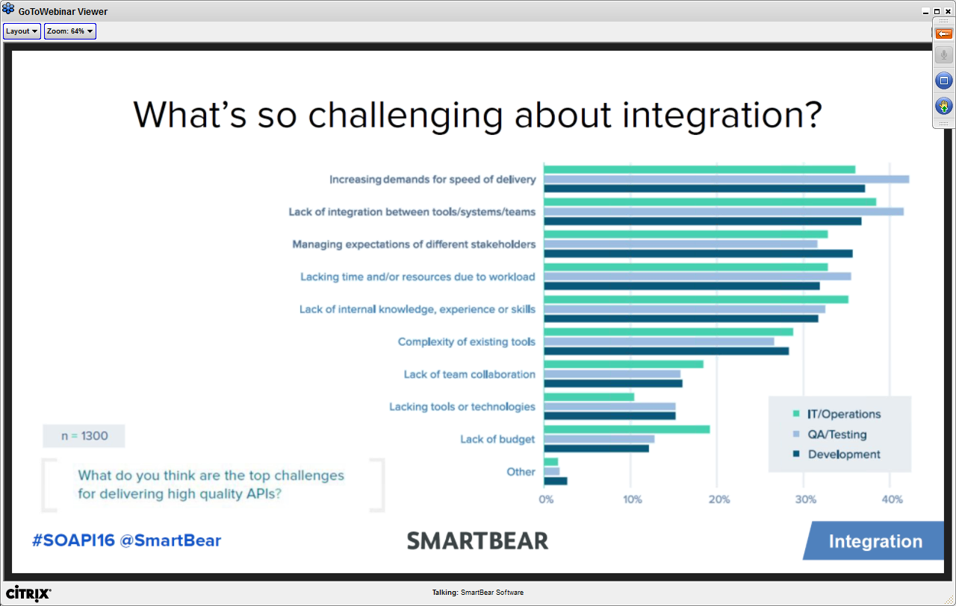

* Integrating tools into their own environment was more important evaluation factor (connecting tools in their tool-chain), more than cost

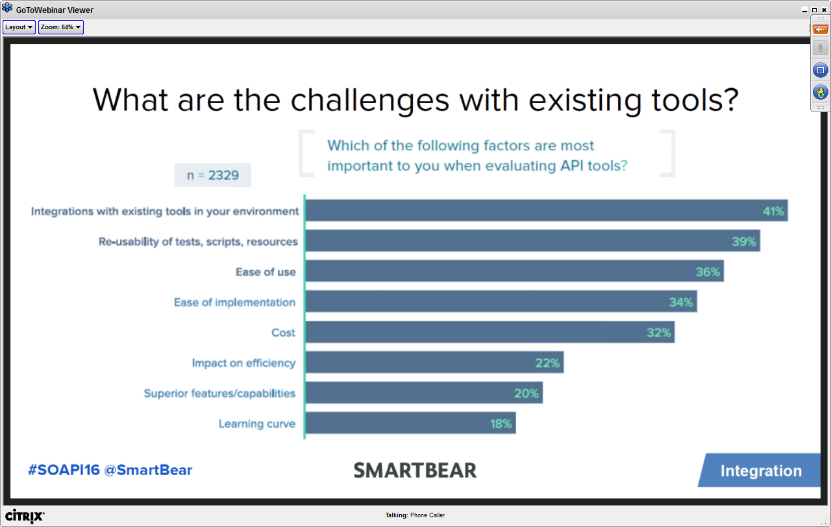

* It is easy to find a tool, hard to find the right tool
  + What people want
* How does documentation help in terms of tool inter-compatibility

QA

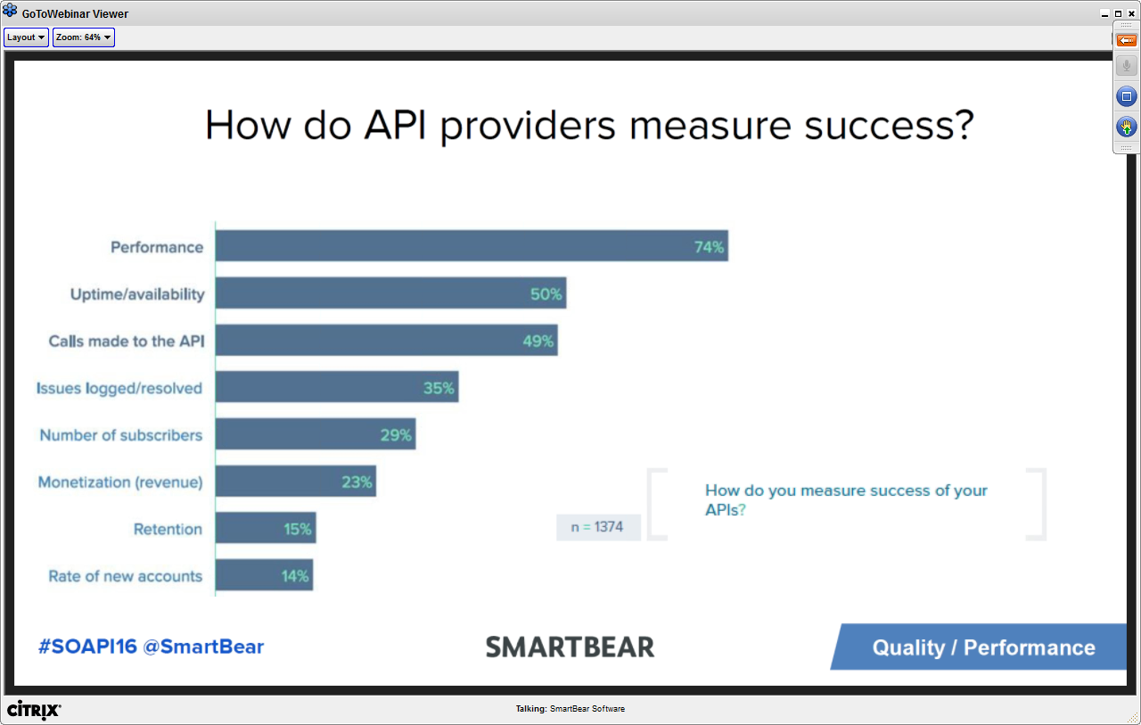

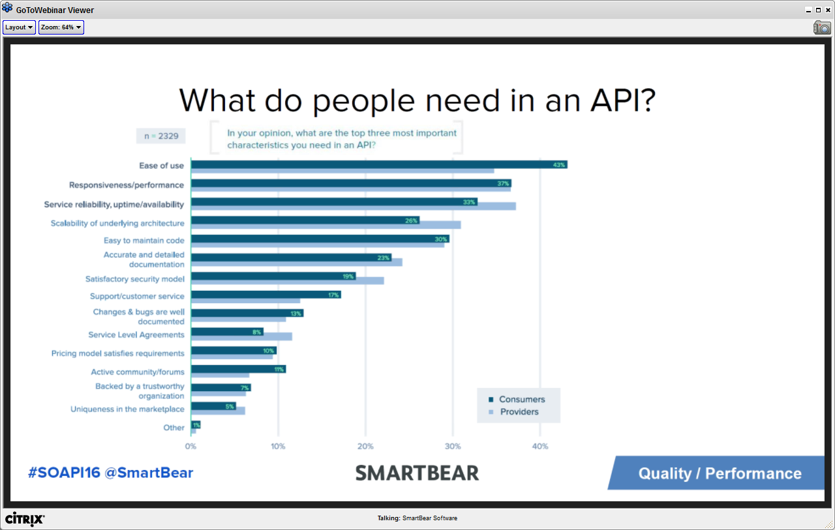

* What do you need in an API
  + Emphasis on performance
  + API Product management as a discipline has just started to grow
    - Success factors can be retention and new account
  + Busy developer is going to choose whatever it is easy
    - Ease of use is highest
  + What panelist are saying is due to the low maturity of the industry on APIs, these are of high focus. Even though developers adopt easy to use APIs, many of them move off. So as industry matures, it will be important in terms of operations
  + Important thing to note, security was not in the top 5 needs
* What is APIs are now varied
  + REST APIs, SOAP APIs, IOT APIs

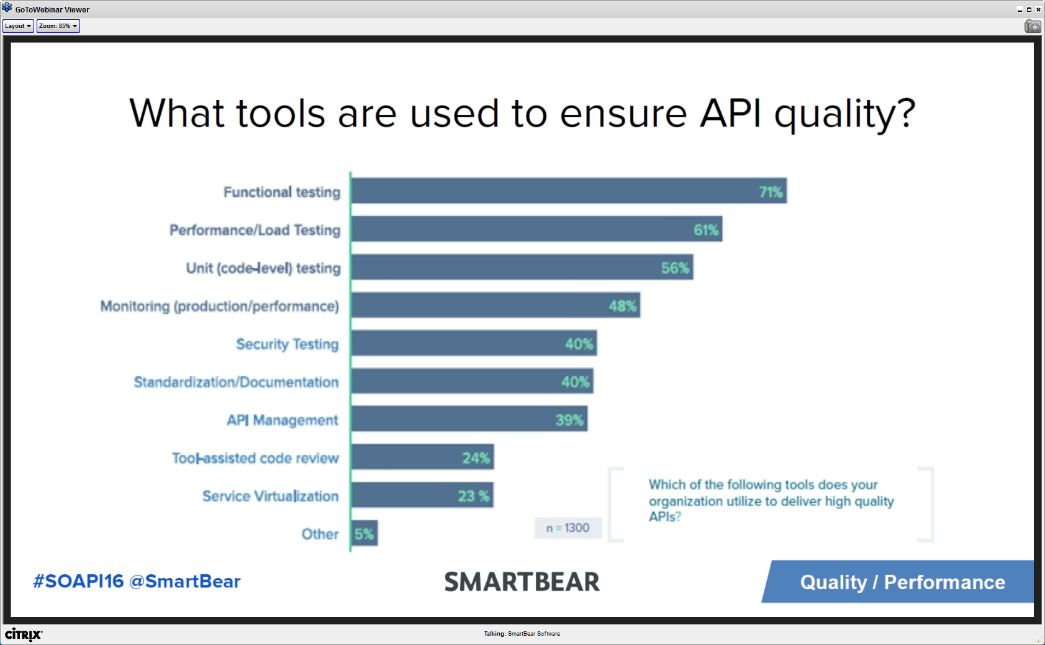

* Are we still treating APIs different than other assets
  + Lower monitoring in production than testing in pre-production

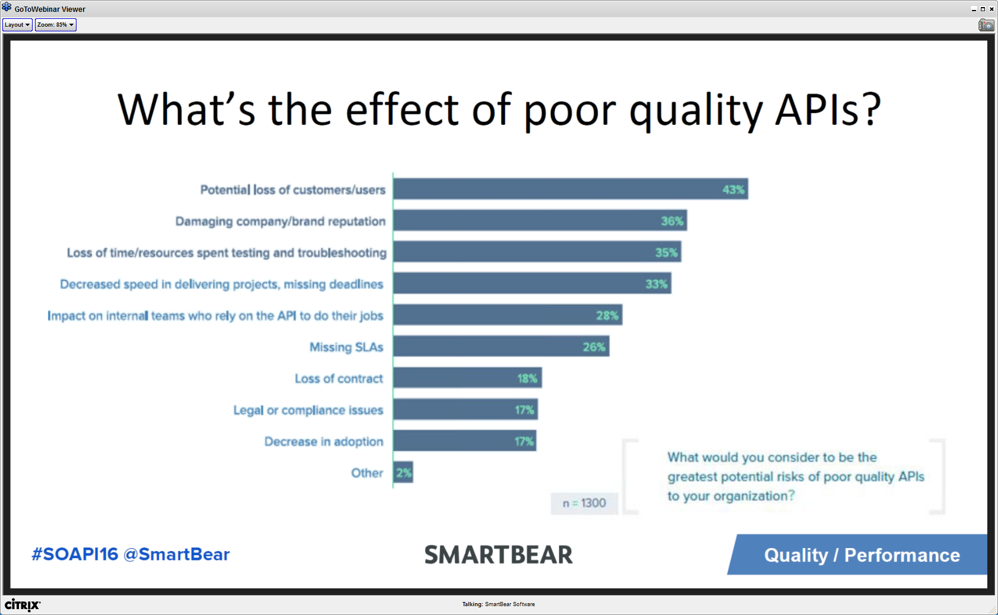

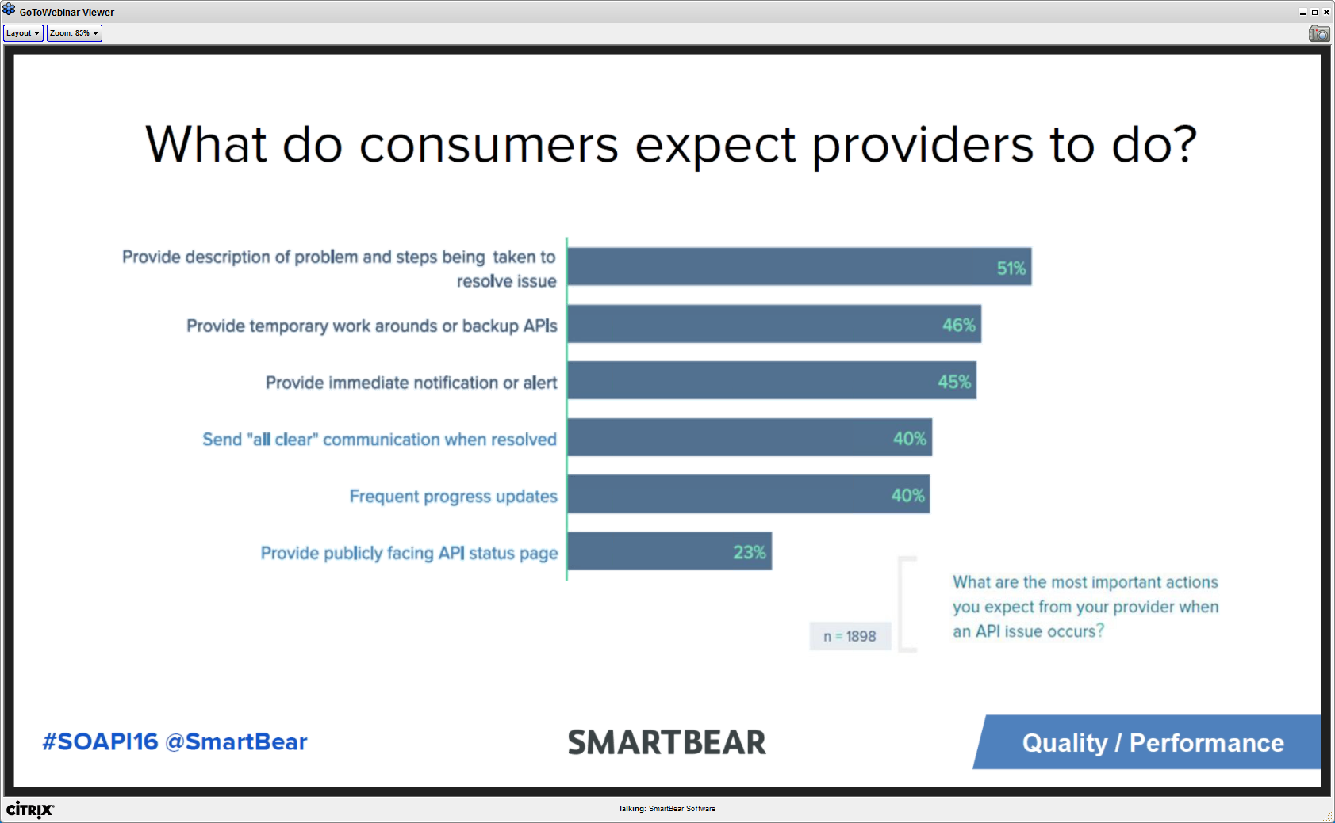

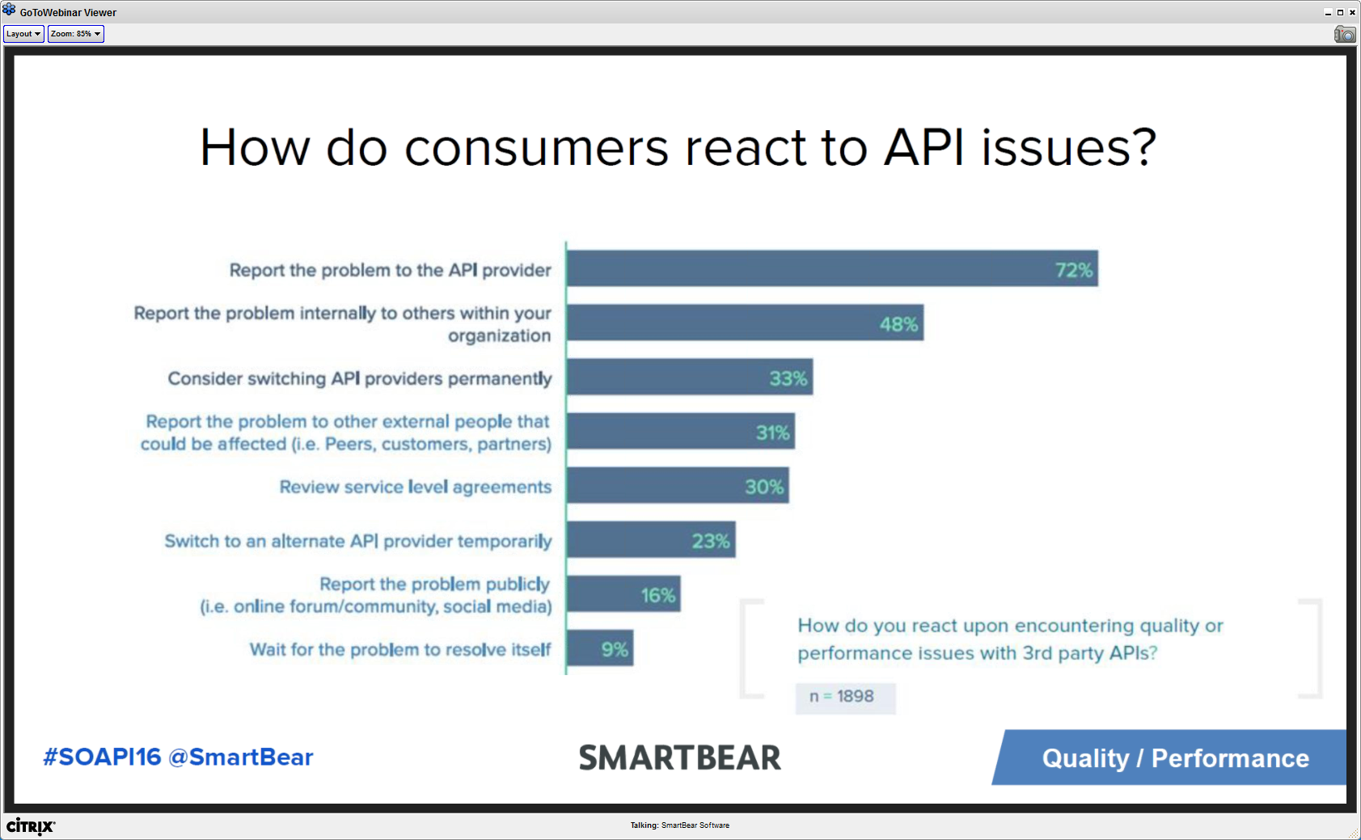

* Are providers measuring retention? (Consumers switching API providers)
* Some items they plan to do a deep dive in – intends to do more surveys in the future

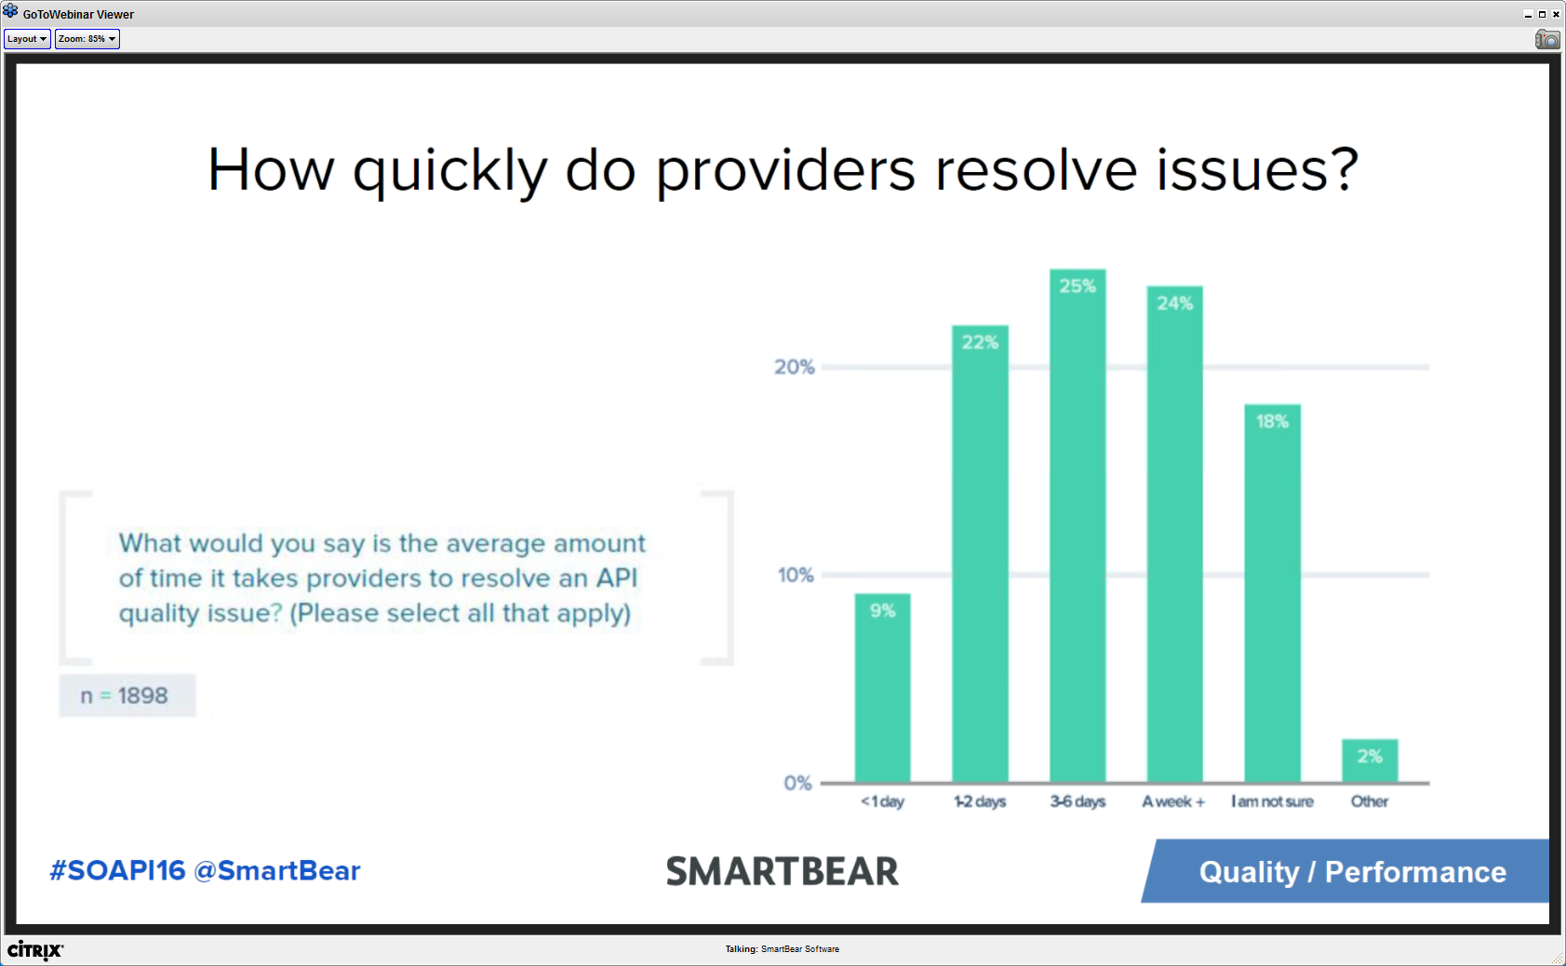

* Pretty long time to resolve issues ~50% in 1 week

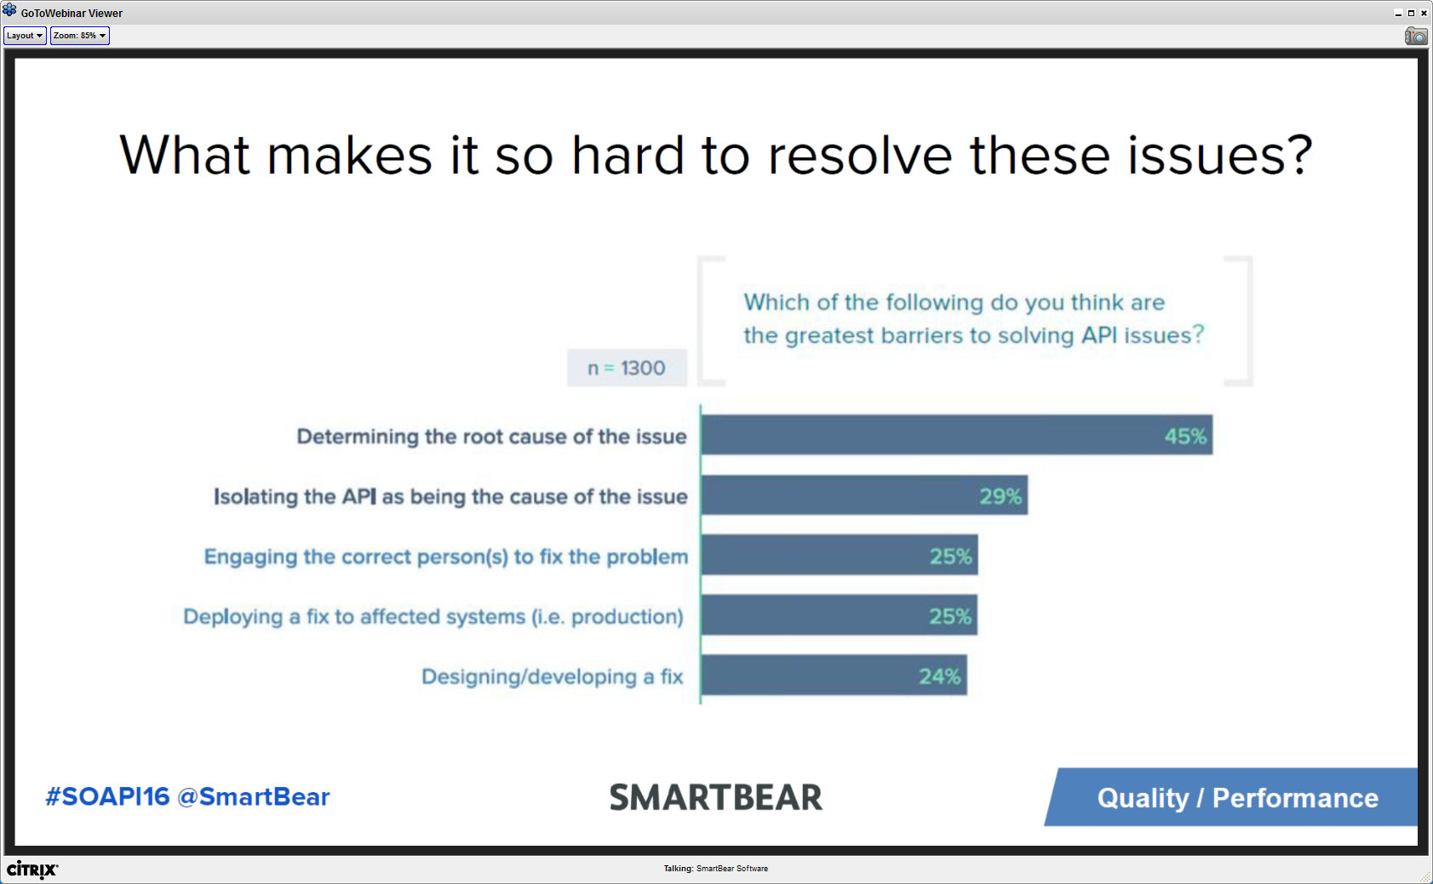

* Why are API issues so hard to resolve?
  + Technology stack for APIs are very complicated and distributed – hence external dependencies
  + Traceability is not the first concern while building an API – hence RCA takes time
  + API architecture is much more complicated than you think – complicated layering in API stack

Takeaways

* Quality & Security – top of mind for people
  + Secure high quality API has a lot of work to do and being expected by consumers
* QA is moving more to a shared responsibility